#1

|  |  |  |  |  |
| --- | --- | --- | --- | --- |
|  | European Call | | European Put | |
|  | Estimated price | Standard error | Estimated price | Standard error |
| VG Time Changed | 7.3624611 | 0.0502044 | 12.00348248 | 0.04563806 |
| VG Diff Gamma | 7.43042828 | 0.05110586 | 11.95911826 | 0.04570866 |
| VG FFT | 7.402404 |  | 12.03764 |  |
| GBM | 8.05231697 | 0.04896859 | 12.73824066 | 0.04516489 |
| GBM FFT | 8.026385 |  | 12.66162 |  |

|  |  |  |  |  |
| --- | --- | --- | --- | --- |
|  | Asian Call | | Asian Put | |
|  | Estimated price | Standard error | Estimated price | Standard error |
| VG | 2.40163391 | 0.02200974 | 9.9371243 | 0.0315784 |
| VG FFT | 2.393005 |  | 10.00268 |  |
| GBM | 2.76876076 | 0.02223861 | 10.43050314 | 0.03152782 |
| GBM FFT | 2.764456 |  | 10.37735 |  |

#2

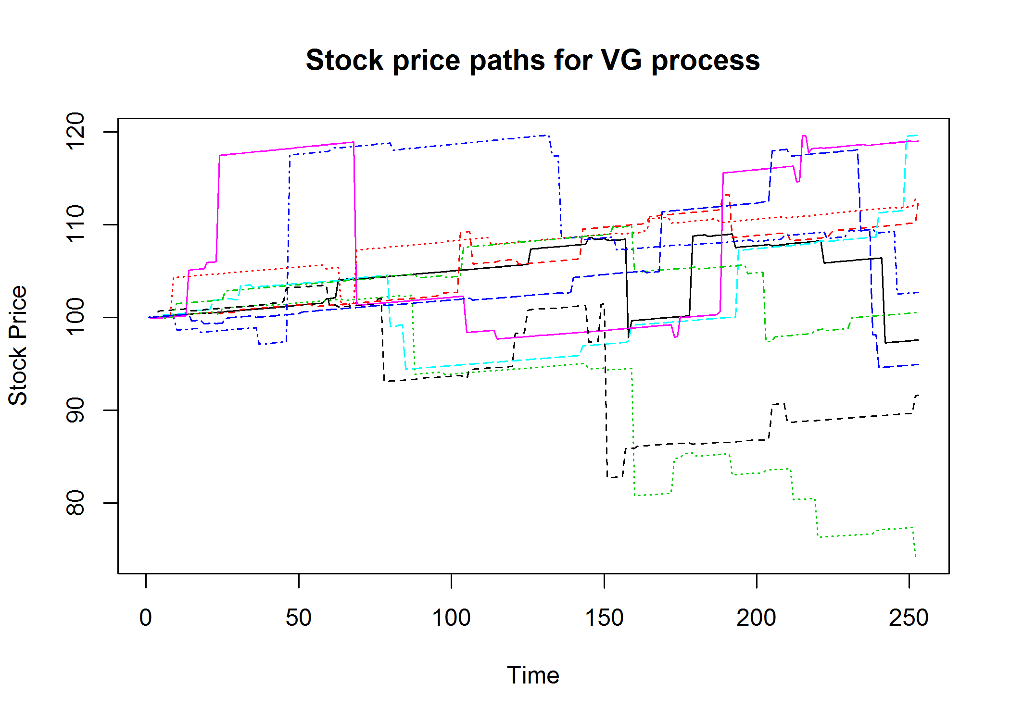

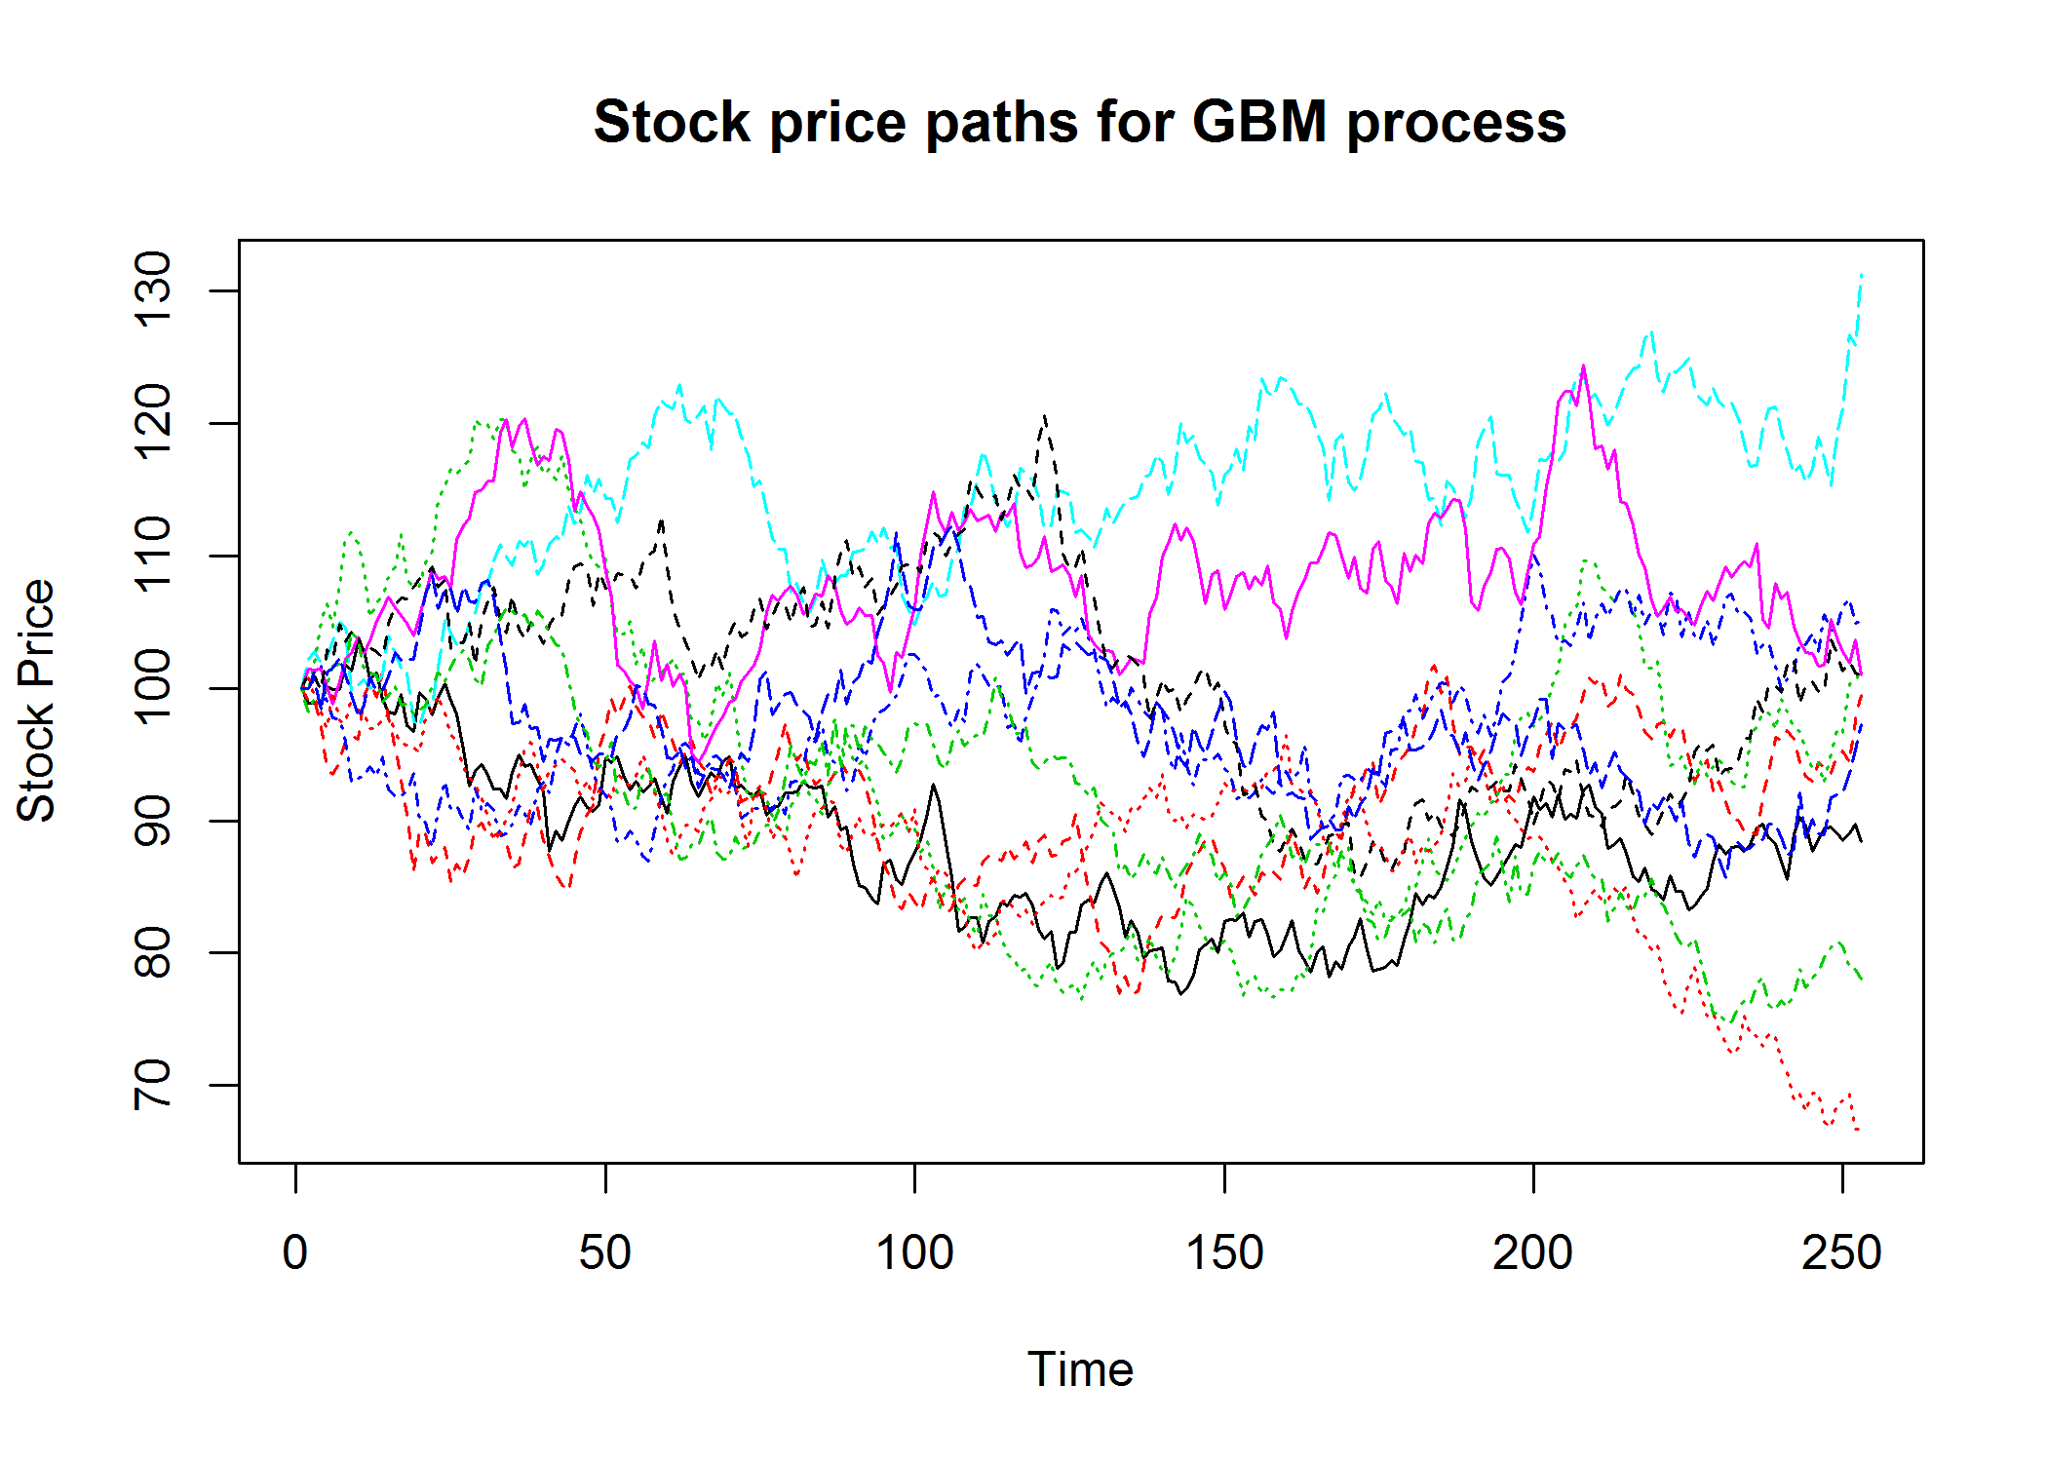

#3 Option prices VS. strike price and time

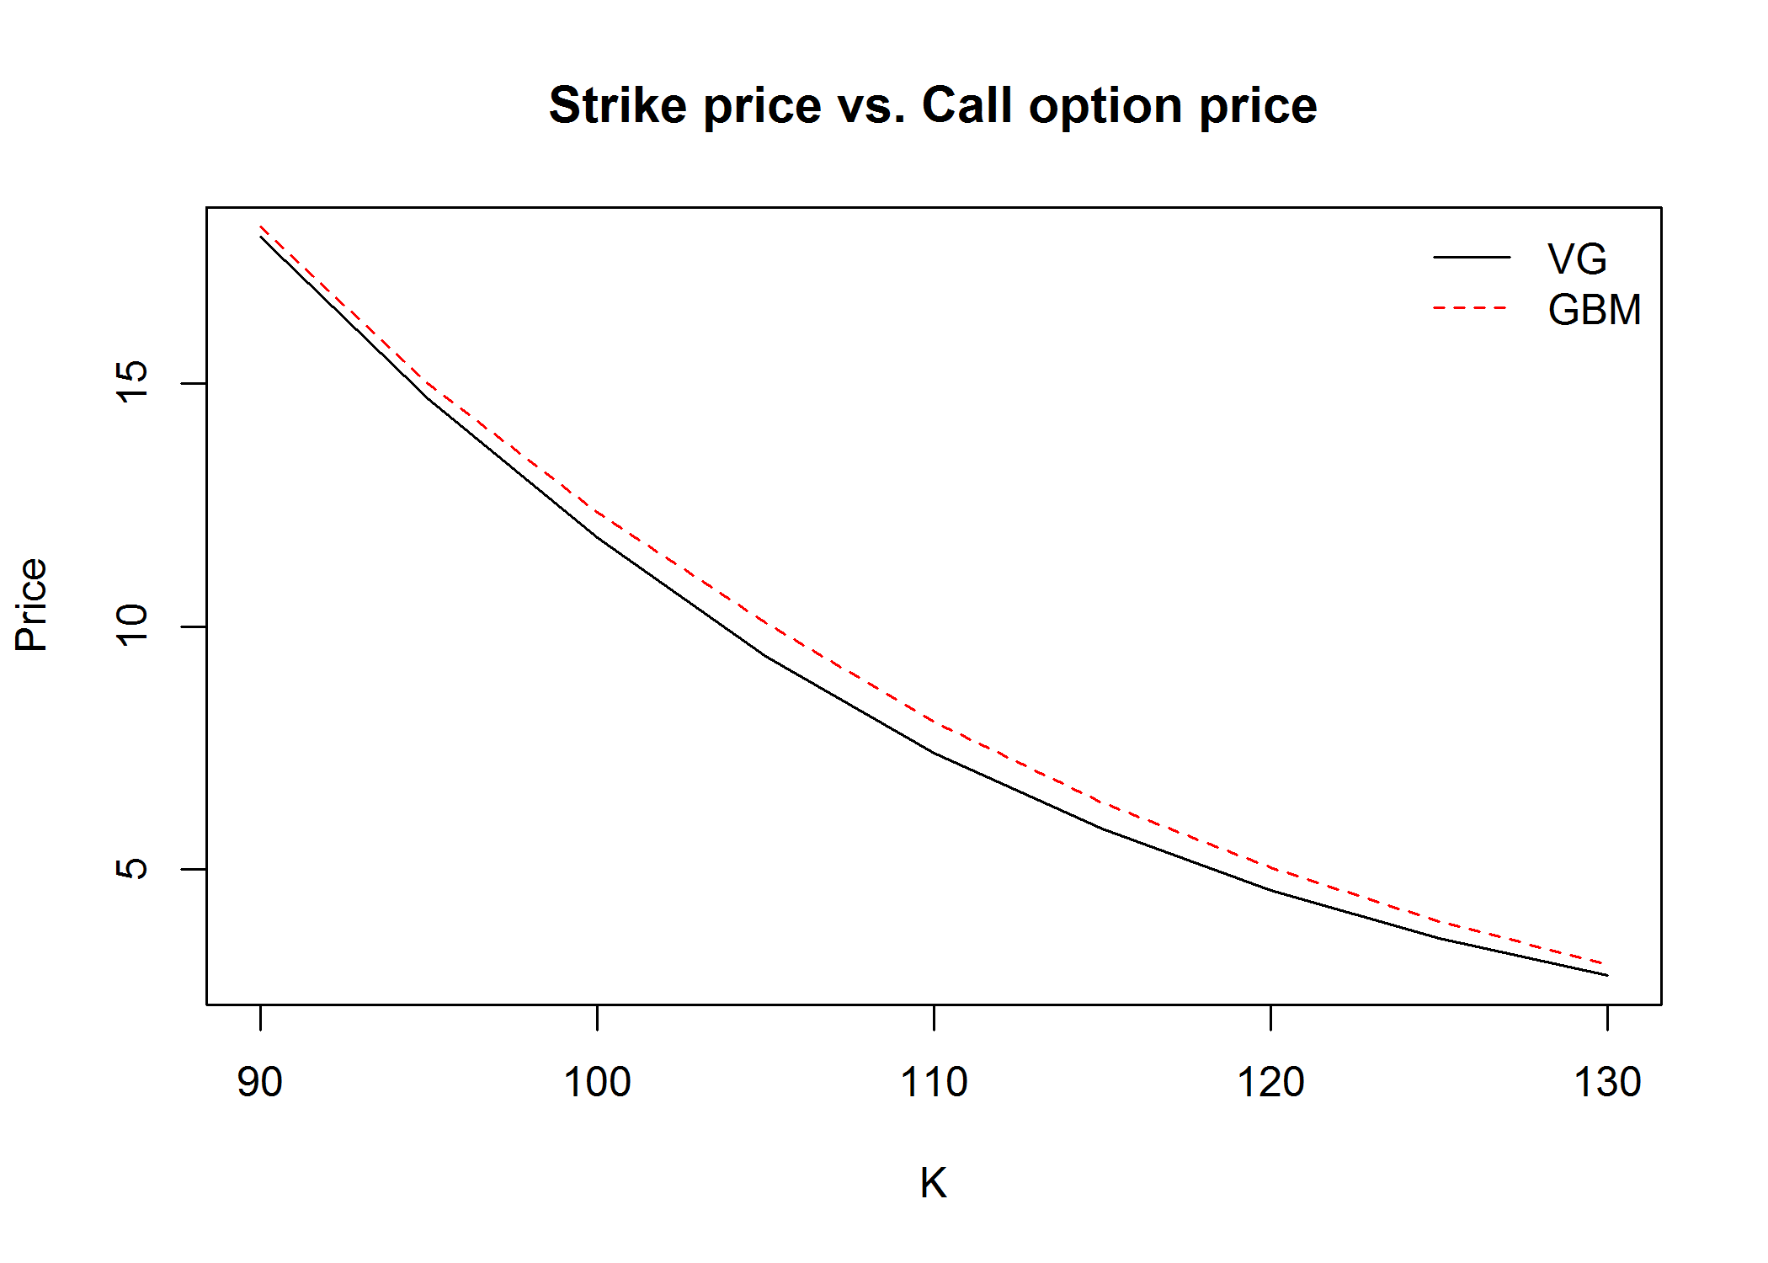

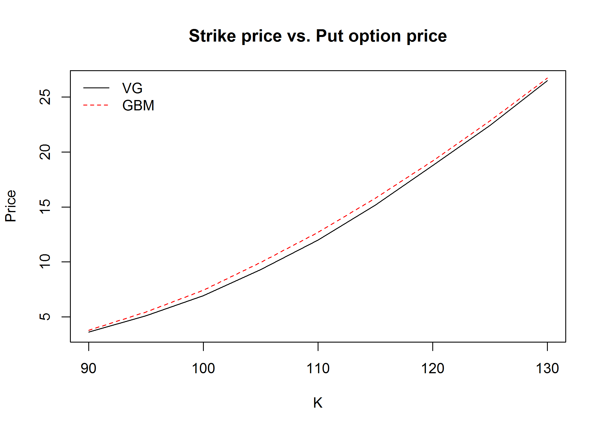

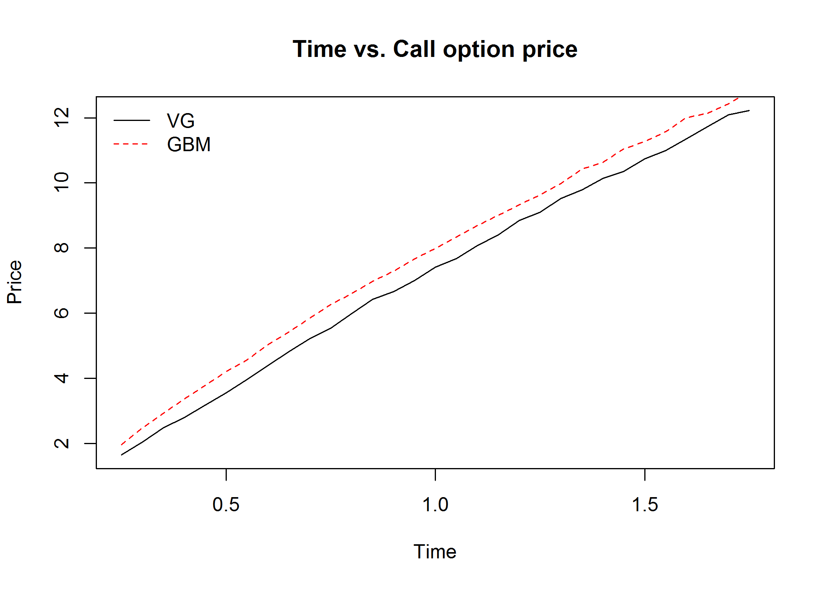

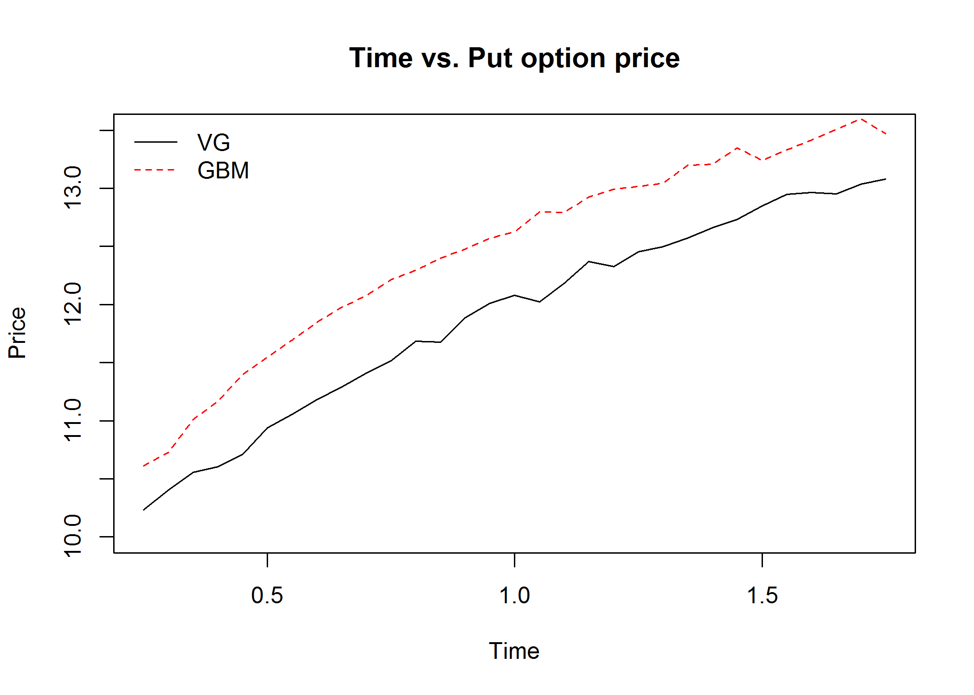

#4 Fit VG distribution

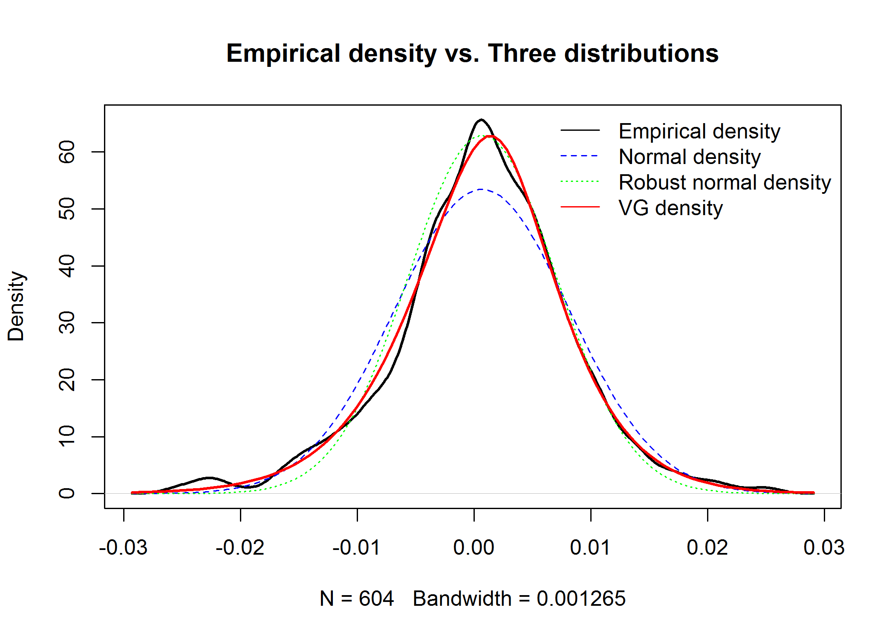

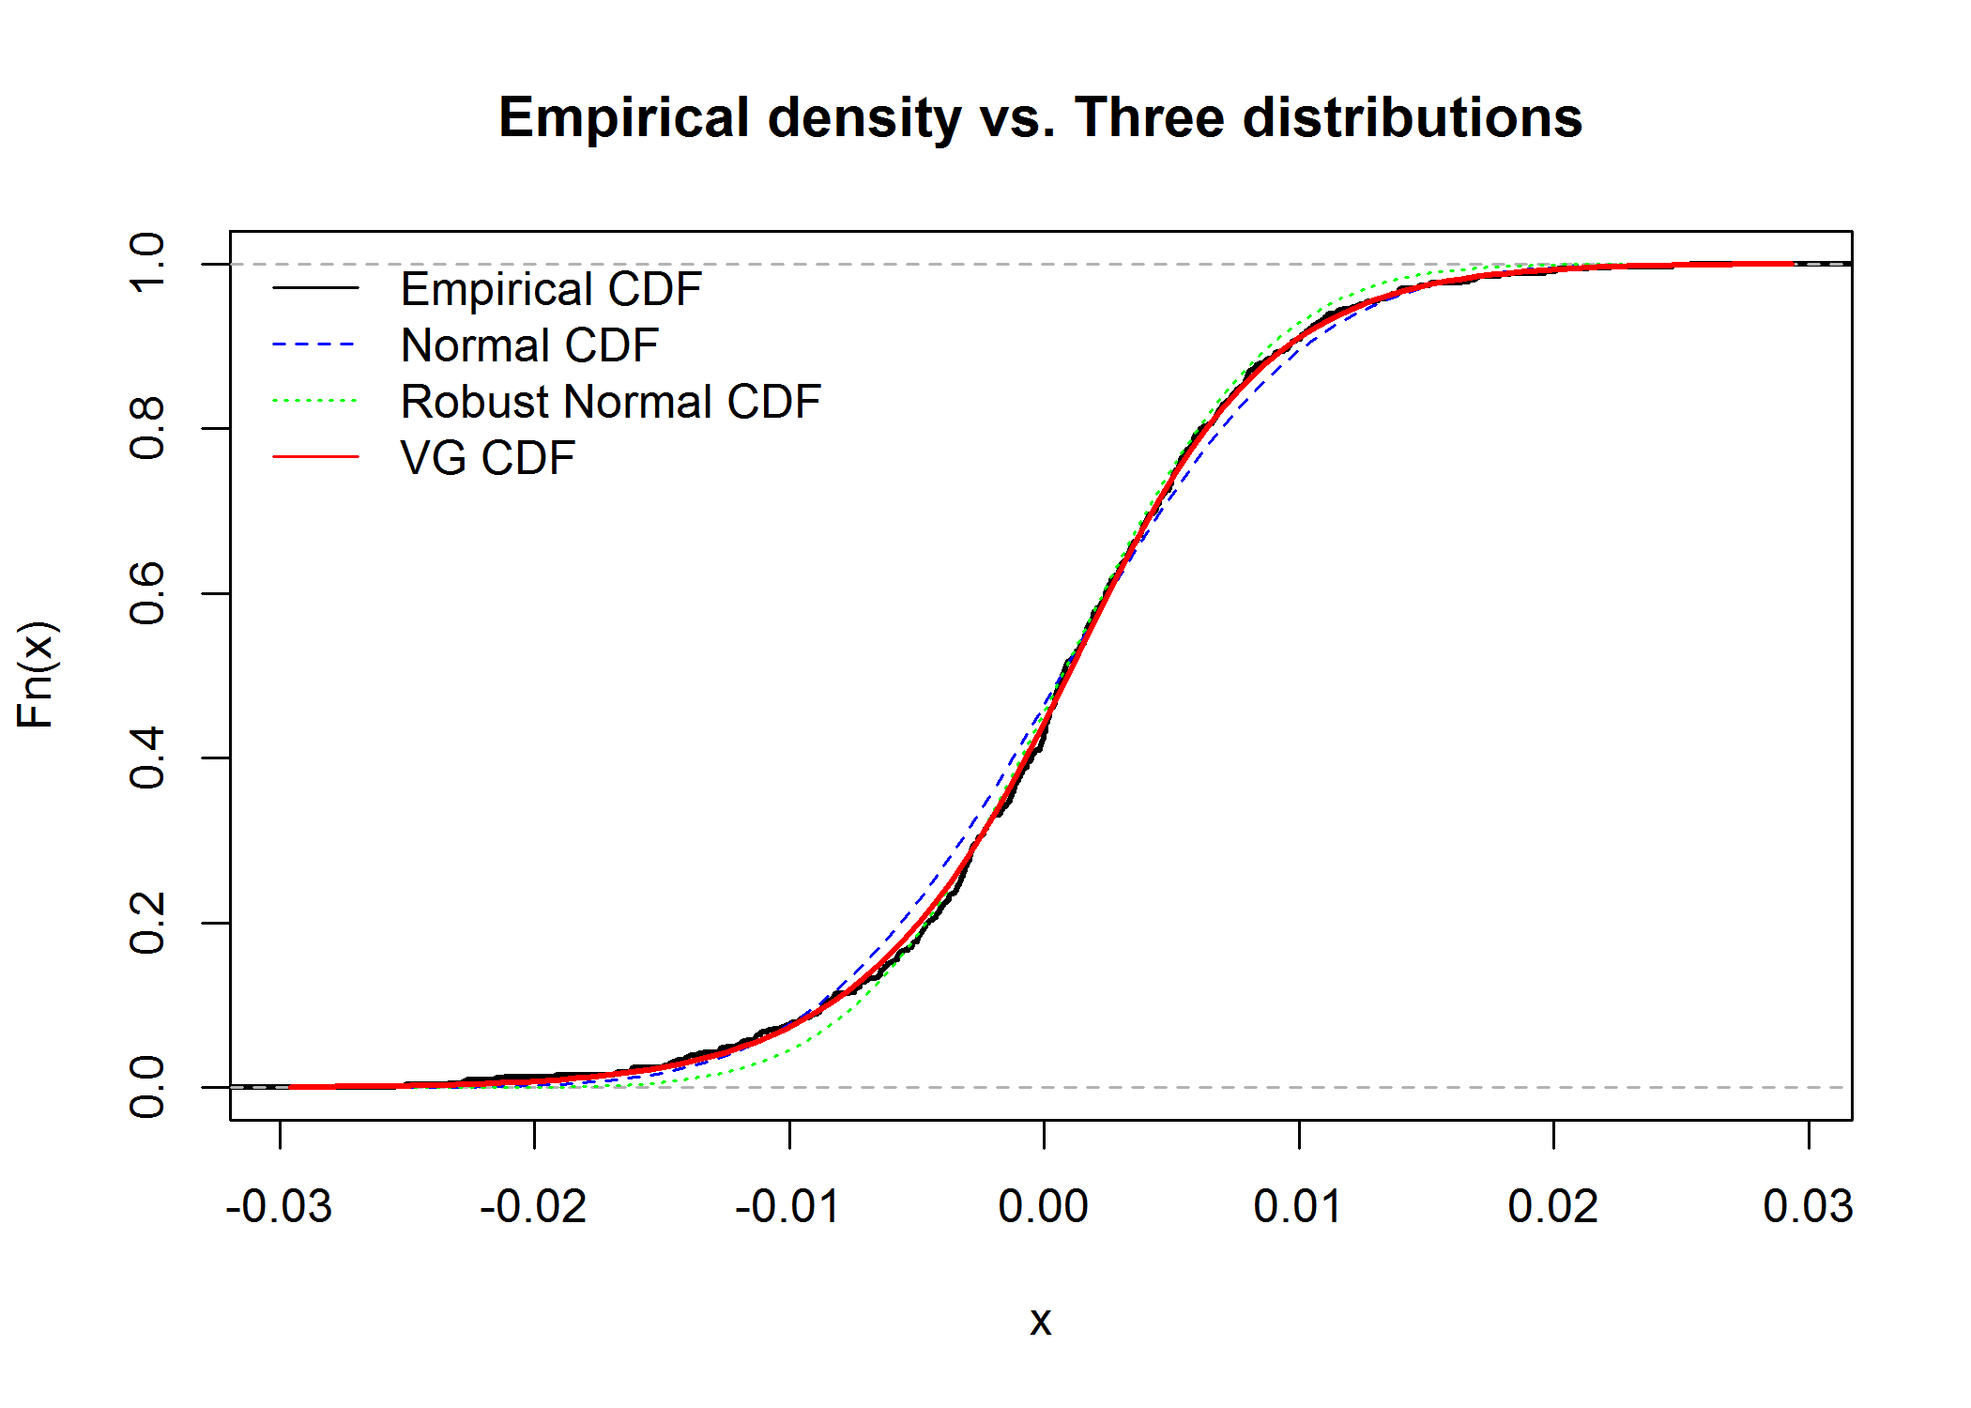

#5 VG distribution vs. different parameters

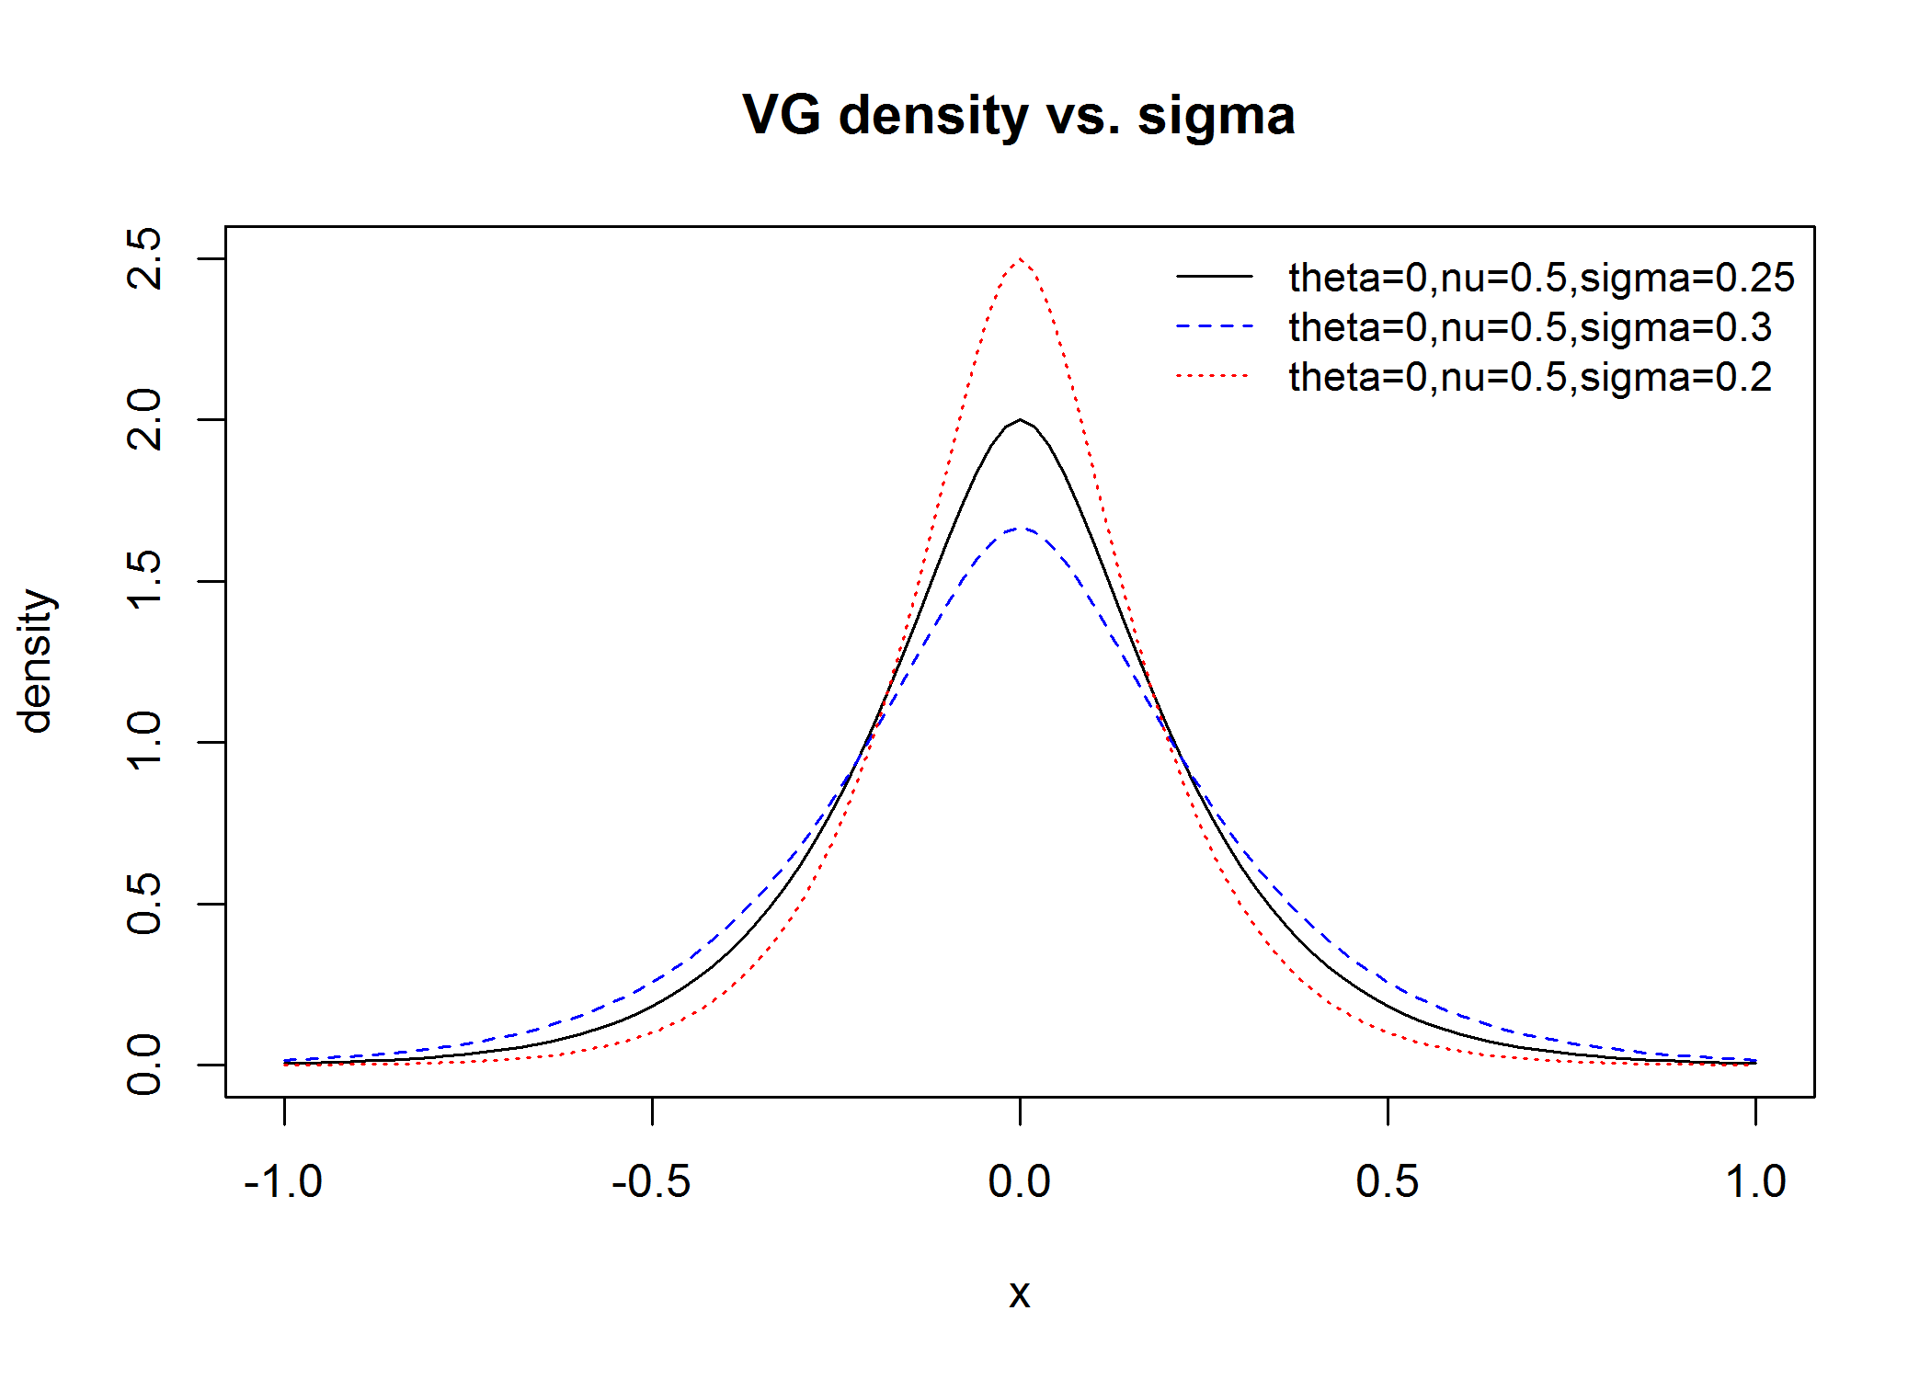

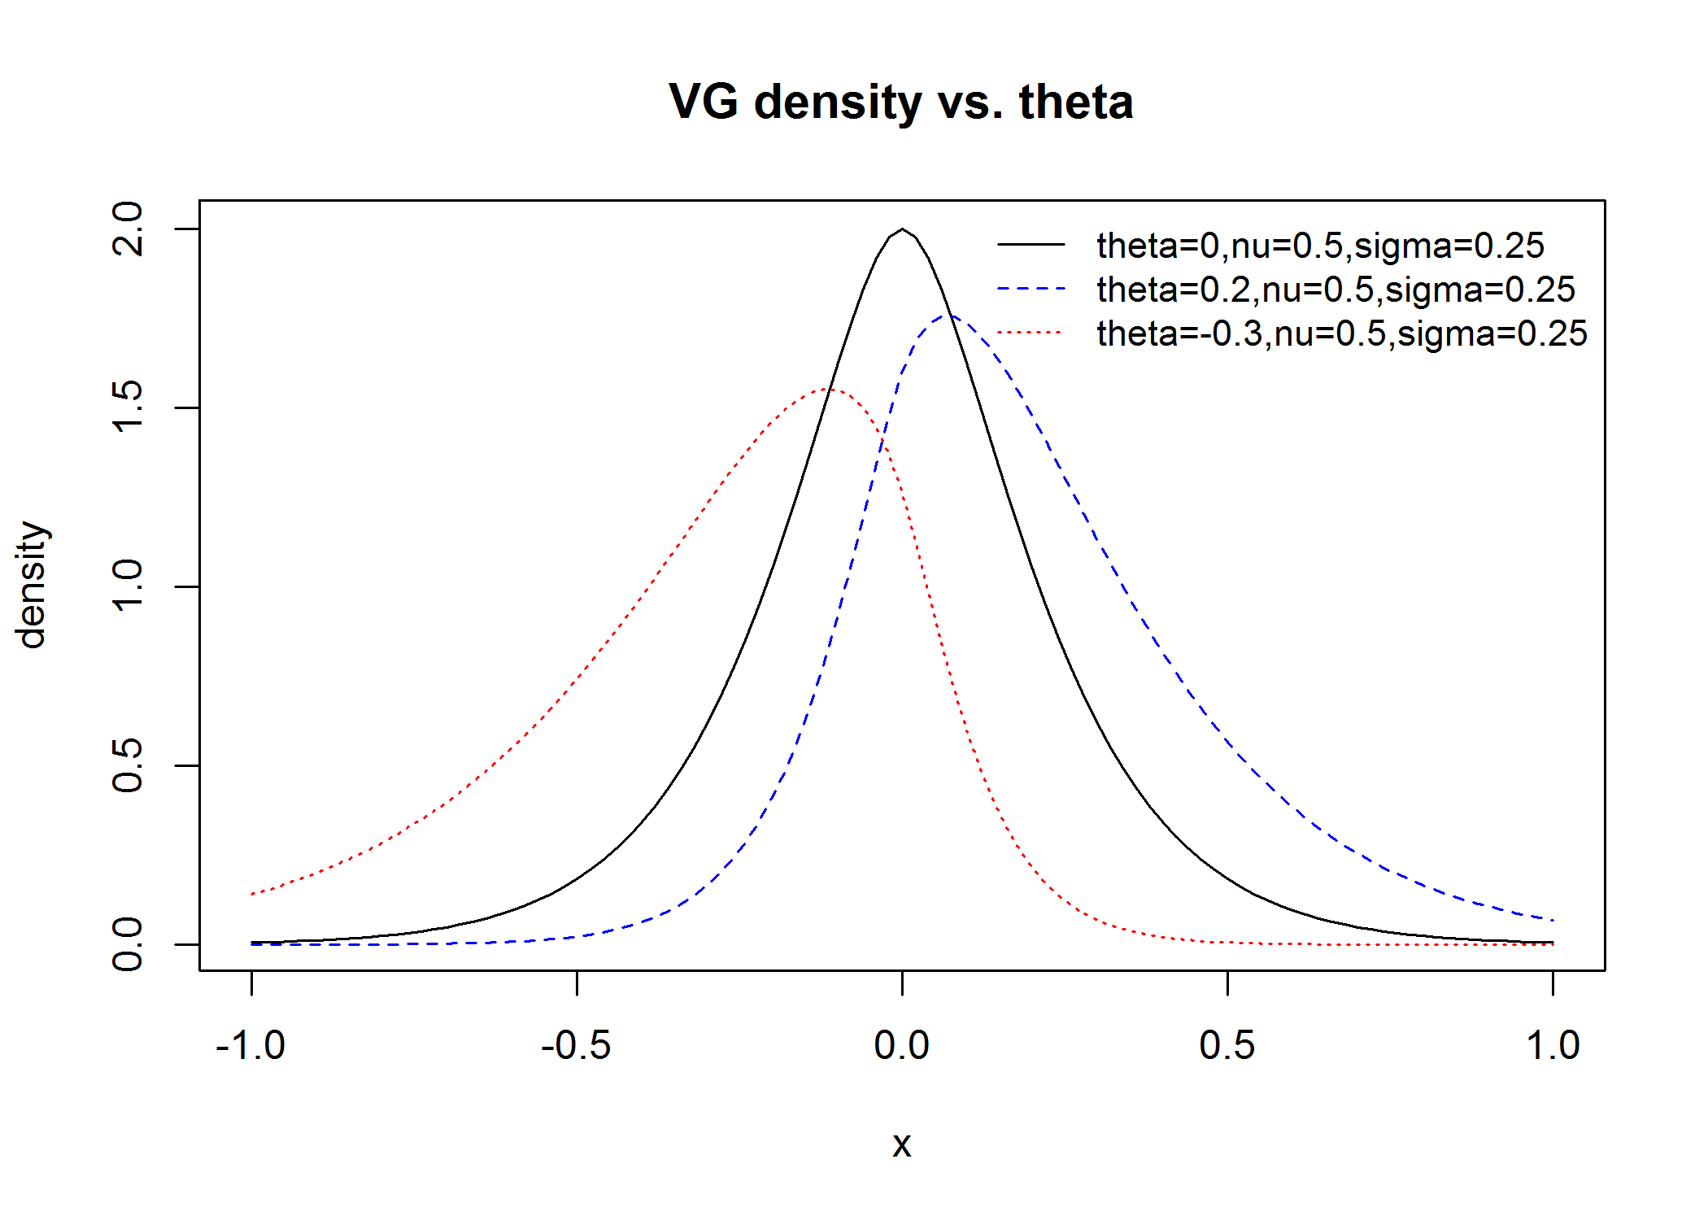

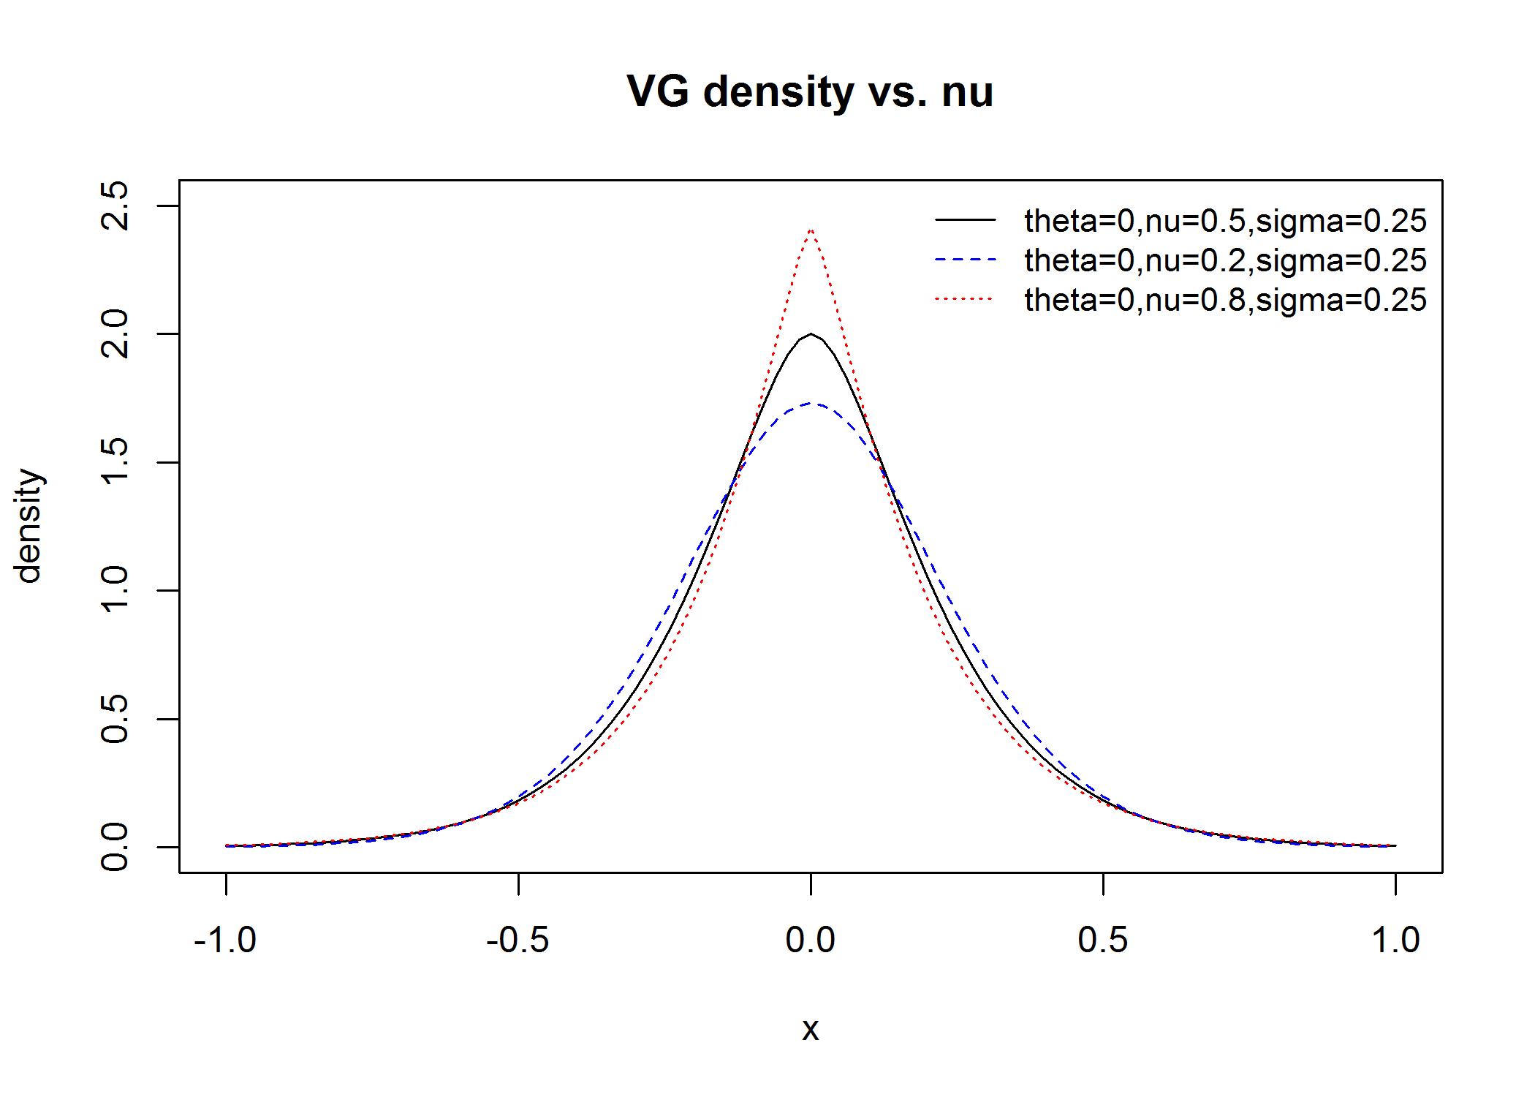

#6 Greeks

|  |  |  |
| --- | --- | --- |
|  | European Call | |
| Delta diff | 0.47934777 | 0.03566071 |
| Delta pathwise | 0.465494395 | 0.001945311 |
| Delta fourier | 0.4653853 |  |
| Gamma diff | 0.09000361 | 0.12400942 |
| Gamma pathwise | 0.018325135 | 0.001374918 |
| Gamma fourier | 0.01978011 |  |
| Rho diff | 39.6033748 | 0.3656007 |
| Rho pathwise | 38.9640694 | 0.1599638 |
| Rho fourier | 39.13612 |  |

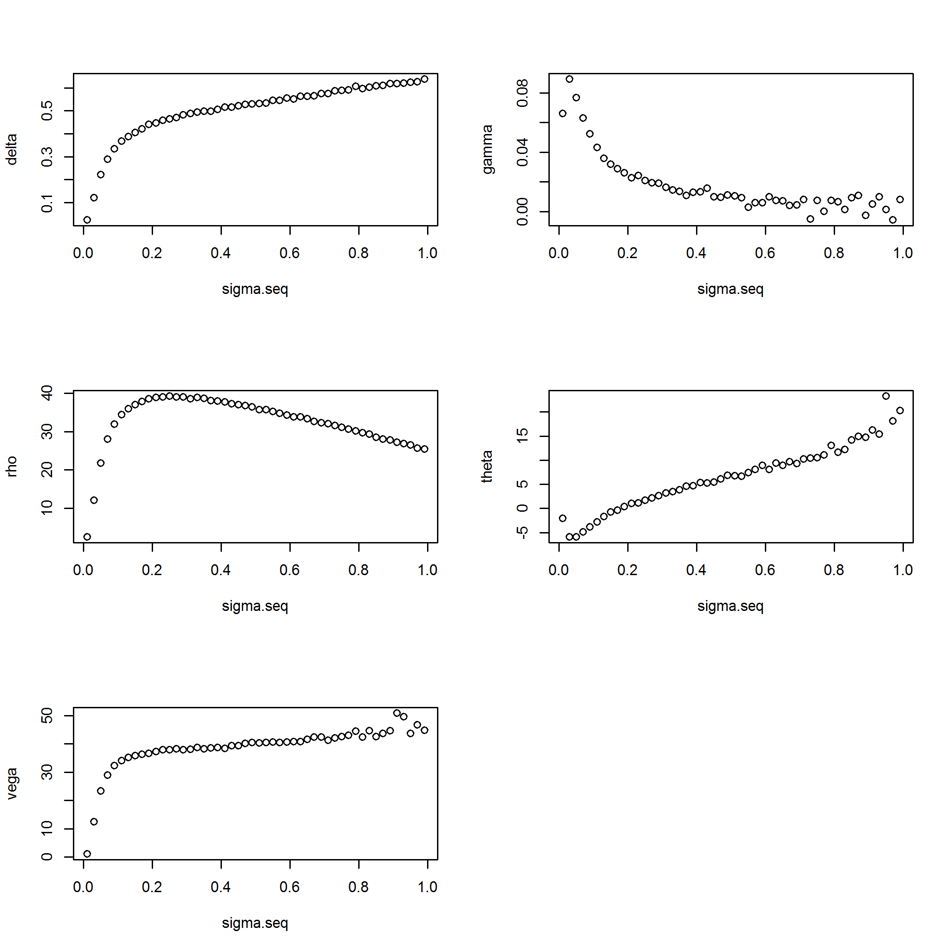

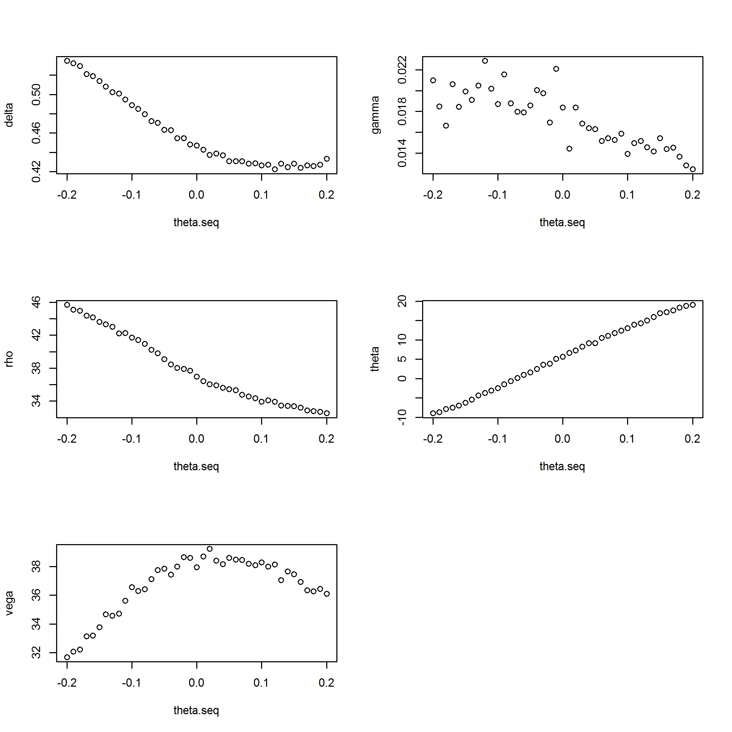

#7 Variance Reduction

Importance sampling

I use the deep OTM put (S0=100, K=45, and the other parameters are the same)

|  |  |  |
| --- | --- | --- |
|  | Estimated price | Standard error |
| VG Diff Gamma | 0.025807280 | 0.001583751 |
| VG Importance Sampling | 0.0237484936 | 0.0005620372 |

Control variates

